CONTROLLER DESIGN

For the controller design, digital controller will be used. However, if reasonable analog controller is found, it can be used, but at the first stage, digital controller will be used. For the microcontroller, Arduino Nano will be used. It can supply PWM signal. In our topology, we should control two switches. They should work simultaneous, so they are at on and off periods in same time. It will be very big challenge for this topology.

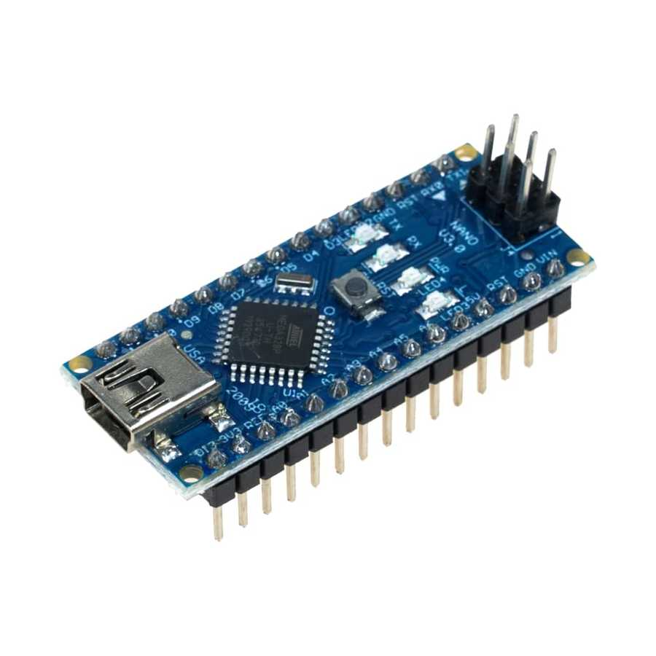

Figure X. Arduino Nano

As we discussed, duty cycle should be limited to 0.5. It is another challenge for the controlling MOSFET’s. Duty cycle algorithm will be determined when the experiments are done. First decision for control algorithm, we should control output voltage and current. For this purpose, we should take feedback from the load. For this purpose, voltage sensing units will be used. According to analog data at Arduino pins, they will be transformed to digital signal, and it will range between the bit number. From this data collection, duty cycle will be controlled. For the observing current at the load, stone resistor will be used with high power rating. On this resistor, voltage value will be measured. Then dividing this value with resistor value give us a current rating at the load.

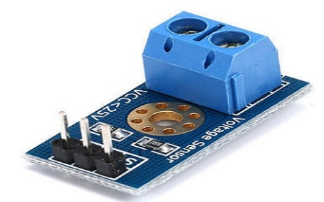

Figure X. Voltage Sensing Unit

Our control algorithm can be seen in block diagram 1.

metin, diyagram, çizgi, ekran görüntüsü içeren bir resim

Açıklama otomatik olarak oluşturuldu

Block Diagram 1. Control Loop for Duty Cycle

So, with this specification, voltage and current sensing should be very sensitive and error margin will be very low. It will be challenge for us and we should consider this situation.

After the completing the project, digital screen which shows voltage rating of the battery and current value of the load will be designed.